Technical Design Document

# Introduction

This document will detail the class diagrams for each of the iterations of the project, showing how the various classes relationship grew and were refined over the course of the project.

*0.3 high level overview

Created by Conor McDonagh Rollo

Computer Games Development (C00260445)

Table of Contents

Introduction 1

Legend Terrain 0.1 3

Object 3

Textured Object 3

Terrain 4

Plane 5

Sprite 6

Engine 6

Game 7

Legend Terrain 0.2 7

GameObject 7

MeshGameObject 8

Engine 8

Player 9

Legend Terrain 0.3 10

GameObject 10

Textured Object 10

Terrain 11

Noise 12

Input 12

Engine 12

Generator 13

# Legend Terrain 0.1

Each graph will be split into inheritance and collaborative graphs, as long as the class uses inheritance.

## Object

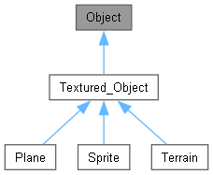

## Textured Object

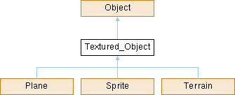

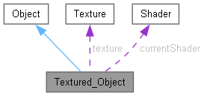

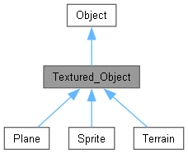

## Terrain

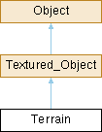

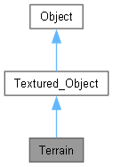

## Plane

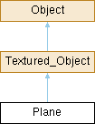

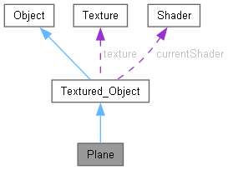



## Sprite

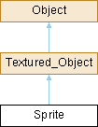

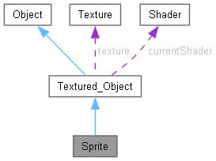

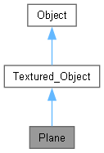

## Engine

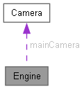

## Game

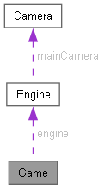

# Legend Terrain 0.2

The project expanded a lot in terms of class relationships since 0.1.

## GameObject

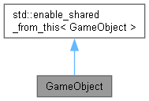

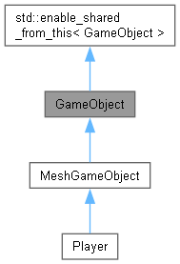

## MeshGameObject

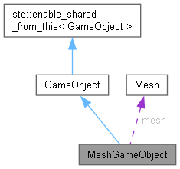

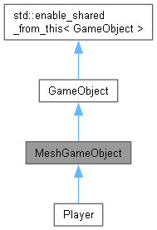

## Engine

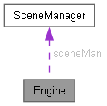

## Player

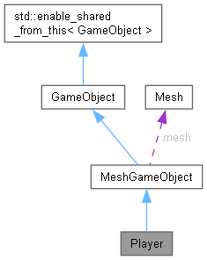

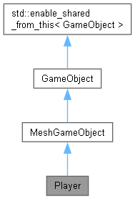

# Legend Terrain 0.3

This is the final merge of the 2 previous iterations.

## GameObject



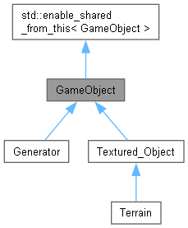

## Textured Object

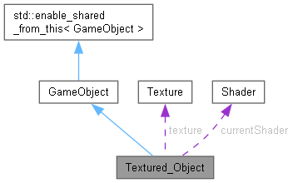

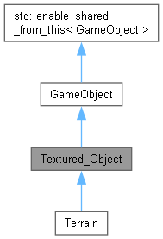

## Terrain

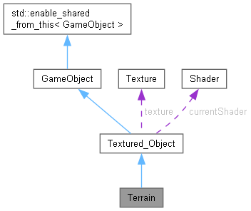

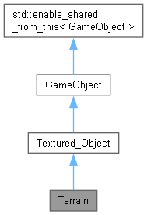

## Noise

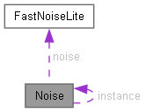

## Input

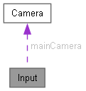

## Engine

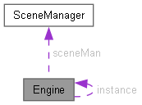

## Generator

